Pollution Incident Response Management Plan
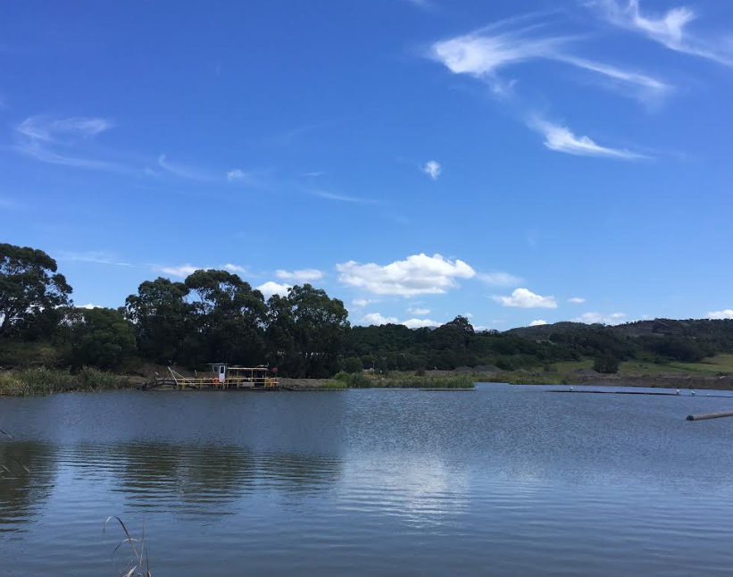

Dunmore Sand and Soil

Version 13: 23 May 2022

DOCUMENT CONTROL SHEET

Version | Date | Prepared By | Approved By | Revision Details
01 | 20 Aug 2012 | Rod Johnson | Rod Johnson | Document Created
02 | 21 Nov 2012 | Philip Paterson | Rod Johnson | Document control sheet added  Incidents updated  Chemical volumes added
03 | 12 Apr 2013 | Nathan Jeffery | Rod Johnson | Format Changes  Added additional maps  Updated ABN No
04 | 09 Sept 2013 | Mel Goodall | Rod Johnson | Contacts updated  Map of dredge pond area added  Immediate Notification quick reference sheet added
05 | 19 Nov 2014 | Philip Paterson | Rod Johnson | Contacts Updates
06 | 19 March 2015 | Mel Goodall | Rod Johnson | Contacts Updates
07 | 10 May 2016 | Ronnie Lawton | Rod Johnson | Format Changes  Contacts Details Updates  Plans/Maps Updated  Added Incident Response Action
08 | 2 June 2017 | Ellie Randall | Brad Subotic | Contact Detail Updates  Incident details #12 updated
09 | 30 July 2018 | Ben Williams | Brad Subotic | Updated maps  Minor Format Changes  Updated contact details  Added Incident #13
10 | 26 Aug 2019 | Ben Williams | Rod Johnson | Updated format to match new PIRMP template  Refined incident numbers
11 | 27 May 2020 | Ben Williams | Rod Johnson | Update map for Incident #3  Update PIRMP Drill details  Update site contacts  Update NRAR contacts  Insert compliance table into Appendix to reflect EPA PIRMP Guidelines March 2020
12 | 20 May 2021 | Ben Williams | Shoanne Labowitch | Contacts and PIRMP Drill update
13 | 23 May 2022 | Ben Williams | Brodie Bolton | Contacts and PIRMP Drill update

Current Revision | Date Implemented | PIRMP Test Schedule | Date for Next Review
12 | 23 May 2022 | 12 months | 23 May 2023

CONTENTS TABLE
1. DOCUMENT CONTROL SHEET 2
PART A: COMPLIANCE REQUIREMENTS, POLLUTION INVENTORIES AND RISK ASSESSMENTS
2. PURPOSE 5
3. LEGISLATIVE REQUIREMENTS 5
4. DEFINITION OF A ‘POLLUTION INCIDENT’ 8
5. SCOPE 8
6. SITE LAYOUT 8
7. POTENTIAL POLLUTING SUBSTANCES 11
8. ROLES AND RESPONSIBILITIES 14
9. INTERNAL POLLUTION INCIDENT REPORTING 15
10. EXTERNAL POLLUTION REPORTING 16
11. POLLUTION INCIDENT AUTHORITY CONTACT LIST 17
12. INCIDENT REPONSE TRAINING 18
13. PIRMP TESTING 20
14. PIRMP REVIEW 20
14.1. EVENT BASED 20
14.2. TIME BASED 21
15. APPENDIX A: RISK ASSESSMENT ON POTENTIAL IMPACTS 22
PART B INCIDENT RESPONSE ACTIONS AND NOTIFICATION LOGS
16. PIRMP RESPONSE ACTIONS AND MAPS 24
17. POLLUTION INCIDENT NOTIFICATION LOG 30
18. IMMEDIATE NOTIFICATION SHEET SUMMARY 32

PART A: COMPLIANCE REQUIREMENTS, POLLUTION INVENTORIES AND RISK ASSESSMENTS

PURPOSE
The purpose of the Dunmore Sand and Soil (DSS) Pollution Incident Response Plan is to:
- Provide direction to the staff in responding to pollution incidents at the Dunmore operations;
- Ensure timely communication about a pollution incident is provided to staff at the premises, the Environment Protection Authority (EPA), other relevant authorities specified in the Protection of the Environment Legislation Amendment Act (POELA Act) (including Shellharbour City Council, NSW Ministry of Health, Safework NSW, and Fire and Rescue NSW) and persons outside the operations who may be affected by the impacts of a pollution incident that is not trivial;
- Minimise and control the risk of a pollution incident by identifying key risks and planned actions to minimise and manage those risks;
- Detail the training requirements for this plan, identifying persons responsible for implementing it, and ensuring that the plan is regularly tested for accuracy, currency and suitability.
- A hard copy of the PIRMP is to be kept on the site environmental board in the DSS Main Office. A soft copy of the PIRMP and EPL 11147 is made available online https://www.boral.com.au/our-commitment/environmental-reporting.
This document is split into two sections:
Part A details the relevant legislative and regulatory requirements for PIRMP’s based on NSW EPA Guidelines for Pollution Incident Response Management Plans (March 2020).
Part B details the specific incident response actions, maps and notification logs for site personnel to use in the case of an incident.

LEGISLATIVE REQUIREMENTS
The specific requirements for a Pollution Incident Response Management Plan (PIRMP) are set out in Part 5.7A of the POEO Act and the Protection of the Environment Operations (General) Regulation 2009 (POEO(G) Regulation). Part 3A of the POEO Act and the Protection of the Environment Operations (General) Regulation 2009 (POEO(G) Regulation) describes specific components and requirements of a PIRMP.
Table 1 summarises the location of these requirements within the document.
Table 1 Summary of Legislative Requirements of a PIRMP
Section/Clause | Requirement | Location in PIRMP
Part 5.7A POEO Act 1997
147 | (1) For the purposes of this Part—  (a) harm to the environment is material if—  (i) it involves actual or potential harm to the health or safety of human beings or to ecosystems that is not trivial, or  (ii) it results in actual or potential loss or property damage of an amount, or amounts in aggregate, exceeding $10,000 (or such other amount as is prescribed by the regulations), and  (b) loss includes the reasonable costs and expenses that would be incurred in taking all reasonable and practicable measures to prevent, mitigate or make good harm to the environment.  (2) For the purposes of this Part, it does not matter that harm to the environment is caused only in the premises where the pollution incident occurs. | Section 4
153A | The holder of an environment protection licence must prepare a pollution incident response management plan that complies with this Part in relation to the activity to which the licence relates. | EPL 11147 and this document
153C | A pollution incident response management plan must be in the form required by the regulations and must include the following—  (a) the procedures to be followed by the holder of the relevant environment protection licence, or the occupier of the relevant premises, in notifying a pollution incident to—  (i) the owners or occupiers of premises in the vicinity of the premises to which the environment protection licence or the direction under section 153B relates, and  (ii) the local authority for the area in which the premises to which the environment protection licence or the direction under section 153B relates are located and any area affected, or potentially affected, by the pollution, and  (iii) any persons or authorities required to be notified by Part 5.7,  (b) a detailed description of the action to be taken, immediately after a pollution incident, by the holder of the relevant environment protection licence, or the occupier of the relevant premises, to reduce or control any pollution,  (c) the procedures to be followed for co-ordinating, with the authorities or persons that have been notified, any action taken in combating the pollution caused by the incident and, in particular, the persons through whom all communications are to be made,  (d) any other matter required by the regulations. | Section 9 and 10  Section 5  Section 8, 9, 10, 11 and 18, Figures 4-8.  Table 9-11, Section 8, 9, 10,11 and 18  Table 9-11  Section 8, 9, 10 ,11 and 18  Section 10, 17
153D | A person who is required to prepare a pollution incident response management plan under this Part must ensure that it is kept at the premises to which the relevant environment protection licence relates, or where the relevant activity takes place, and is made available in accordance with the regulations. | Section 2
153E | A person who is required to prepare a pollution incident response management plan under this Part must ensure that it is tested in accordance with the regulations | Section 12,13
153F | If a pollution incident occurs in the course of an activity so that material harm to the environment (within the meaning of section 147) is caused or threatened, the person carrying on the activity must immediately implement any pollution incident response management plan in relation to the activity required by this Part | Section 4, Table 9-11
Part 3A POEO(G) Regulation 2009 Pollution Incident Response Management Plans
note: See also 153C (a)-(c) of the POEO Act 1997
98C(1) (a) | A description of the hazards to human health or the environment associated with the activity to which the licence relates, | Table 2, Table 8
98C(1) (b) | The likelihood of any such hazards occurring, including details of any conditions or events that could, or would, increase that likelihood, | Table 8
98C(1) (c) | Details of the pre-emptive action to be taken to minimise or prevent any risk of harm to human health or the environment arising out of the relevant activity | Section 11, Table 2, 8, 9 -11
98C(1) (d) | An inventory of potential pollutants on the premises or used in carrying out the relevant activity | Table 2
98C(1) (f) | A description of the safety equipment or other devices that are used to minimise the risks to human health or the environment and to contain or control a pollution incident, | Table 2, Figure 4-8
98C(1) (g) | the names, positions and 24-hour contact details of those key individuals who:  - are responsible for activating the plan, and  - are authorised to notify relevant authorities under section 148 of the Act, and  - are responsible for managing the response to a pollution incident, | Section 9, 18
98C(1) (h) | the contact details of each relevant authority referred to in section 148 of the Act, | Section 11, 18
98C(1) (i) | Details of the mechanisms for providing early warnings and regular updates to the owners and occupiers of premises in the vicinity of the premises to which the licence relates or where the scheduled activity is carried on | Section 11, Table 9-11
98C(1) (j) | The arrangements for minimising the risk of harm to any persons who are on the premises or who are present where the scheduled activity is being carried on | Section 11, Table 2, 8, 9-11
98C(1) (k) | A detailed map (or set of maps) showing the location of the premises to which the licence relates, the surrounding area that is likely to be affected by a pollution incident, the location of potential pollutants on the premises and the location of any stormwater drains on the premises | Figure 1, Figure 4-8
98C(1) (l) | A detailed description of how any identified risk of harm to human health will be reduced, including (as a minimum) by means of early warnings, updates and the action to be taken during or immediately after a pollution incident to reduce that risk, | Section 11, Table 8, 9-11
98C(1) (m) | The nature and objectives of any staff training program in relation to the plan | Section 12
98C(1) (n) | The dates on which the plan has been tested and the name of the person who carried out the test, | Table 7
98C(1) (o) | The dates on which the plan is updated, | Section 1
98C(1) (p) | The manner in which the plan is to be tested and maintained. | Section 12, 13, 14

DEFINITION OF A ‘POLLUTION INCIDENT’
The definition of a pollution incident is:
“pollution incident means an incident or set of circumstances during or as a consequence of which there is or is likely to be a leak, spill or other escape or deposit of a substance, as a result of which pollution has occurred, is occurring or is likely to occur. It includes an incident or set of circumstances in which a substance has been placed or disposed of on premises, but it does not include an incident or set of circumstances involving only the emission of any noise.”
A pollution incident is required to be notified if there is a risk of ‘material harm to the environment’, which is defined in section 147 of the POEO Act as:
a) harm to the environment is material if:
i) it involves actual or potential harm to the health or safety of human beings or to ecosystems that is not trivial, or
ii) it results in actual or potential loss or property damage of an amount, or amounts in aggregate, exceeding $10,000 (or such other amount as is prescribed by the regulations), and
b) loss includes the reasonable costs and expenses that would be incurred in taking all reasonable and practicable measures to prevent, mitigate or make good harm to the environment.
Licensees are now required to report non-trivial pollution incidents immediately to the EPA, NSW Health, Fire and Rescue NSW, Safework NSW and the local council.

SCOPE
This PIRMP must be followed by employees, contractors and visitors to assist in the early response to, and reporting of, a pollution incident. DSS is owned and occupied by Boral Resources NSW and is operated under Environmental Protection Licence 11147.

SITE LAYOUT
The overall site layout of is shown in Figure 1 below. Figure 2 and 3 shows the operational area and office and parking area respectively. Please note that Part B of this PIRMP contains detailed maps which describe the important details for each pollution incident scenario.
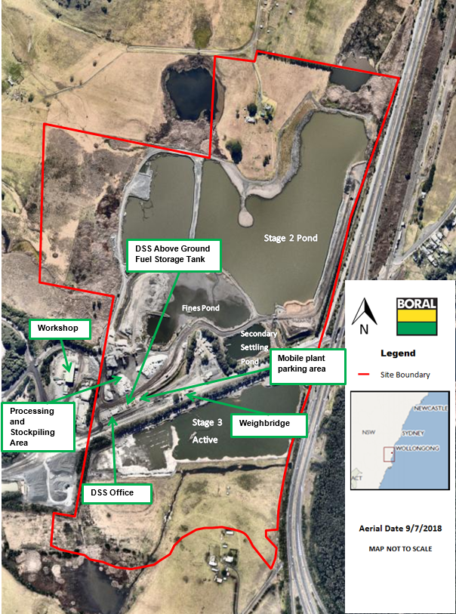
Figure 1 Dunmore Sand and Soil Site Layout

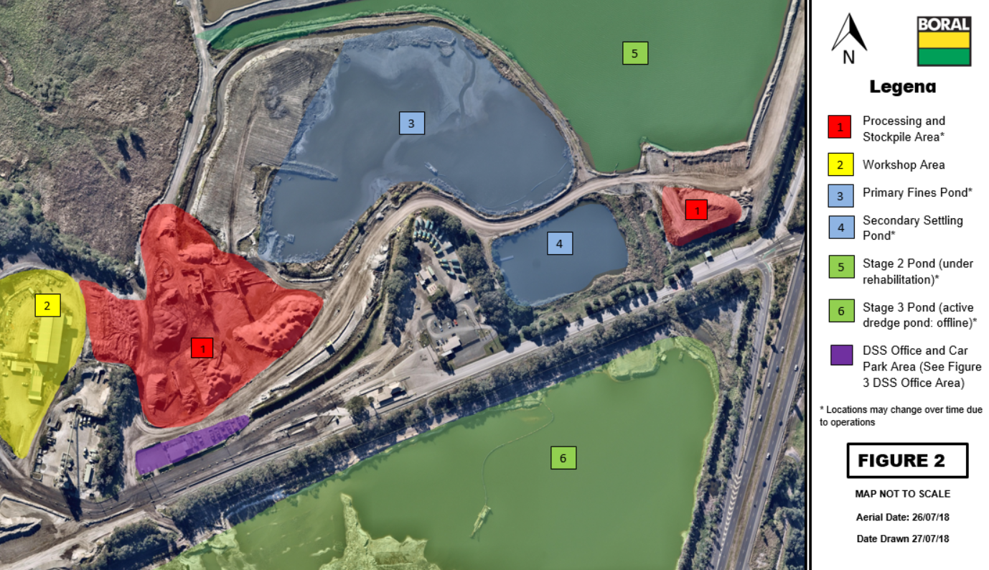
Figure 2 DSS Operational Area
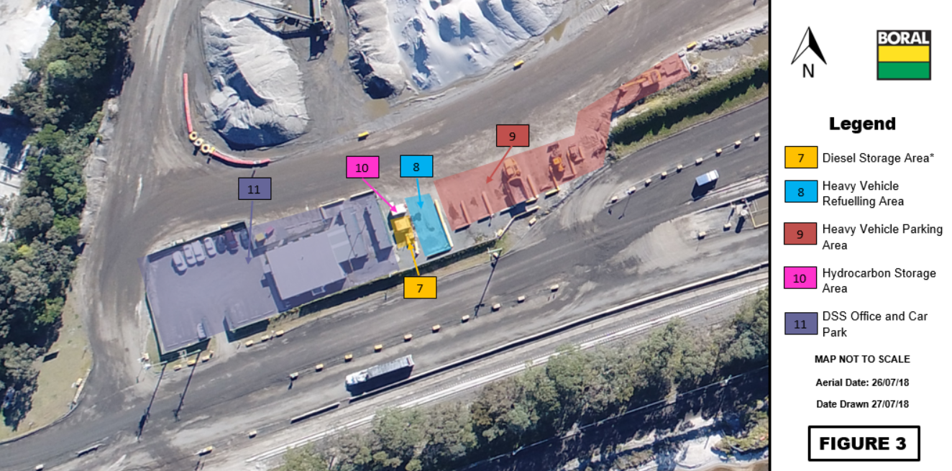
Figure 3 DSS Office and Parking Area
Please note that the workshop area (denoted as 2 in Figure 2) is located outside the Dunmore Sand and Soil site boundary and within the Dunmore Quarry site boundary. Incidents relating to the workshop are described in the Dunmore Quarry PIRMP.

POTENTIAL POLLUTING SUBSTANCES
Table 1 below is an inventory of potential pollutants kept on the premises. This inventory provides a description of the main hazards to human health or the environment, an assessment of the likelihood of the hazards occurring and also includes the current controls and safety equipment and/ or pre-emptive actions in place to minimise or prevent risk of harm to human health or the environment.

Table 2: Inventory of Potential Polluting Substances Initial Assessment
LIST OF POLLUTING SUBSTANCE STORAGES/USES AT SITE: INITIAL ASSESSMENT
(all Chemicals listed in this sheet are to be subjected to a risk assessment located in Appendix A)
Site Name:  Dunmore Sand and Soil |  |  |  |  |  | Responsible Person:  Brodie Bolton |  | Date:  20/05/22
Description of Hazard | Covered under Haz Chemicals/MSDS? | Estimated Amount stored (amounts vary depending on operations) | Location of storage | Map reference | Likelihood of Impact on neighbours |  | Current controls/safety equipment  (Pre-emptive Actions) |  | See Risk Ass & PIRMP Response Action (see Below)
CHEMICALS/FUELS/LUBRICANTS (diesel, Oils, lubricants etc)
Uncontrolled loss of Diesel or other hydrocarbon products that could result in material harm to the environment or human health | Class 3 &  Class 2 | Diesel Storage tanks  10 000L (Stationary Diesel Tank)  1 000L (Fuel trailer)  5 000L (Fuel barge MH 2108)  Excavator (500L)  Loader (480L)  Water Cart (450L)  Precision Screen (250L)  Stacker (100L)  Sand Dredge MH2079 (8 000L Diesel and  500L Hydraulic Fuel)  Sand Dredge MH2075 (1500L Diesel)  Packaged Hydrocarbons  1 100kg oil/solvents and fuels | Diesel Storage Tank  Within tanks of Mobile Plant (location variable however parked up at the same location at the end of every day)  Fuel Barge and Dredge  Hydrocarbon Storage Container | Figure 3 and 4 shows location of mobile plant and storage areas  3: MH2075 Dredge in Fines Pond  6: Fuel Barge and MH2079 Dredge in Stage 3 Pond  7: Stationary diesel tank and waste oil capture  8: Refueling Area  9: Parking Bay Refueling Area  10: Hydrocarbon Storage Container | Rare (1)  Only if substances enter waterways and is transported off-site |  | - Bunded storage tanks  - Bunded and lined re-fueling area  - Designated mobile plant parking areas  - PMP  - Spill kits  - Waste oil capture  - Dangerous goods/flammable material storage cabinets  - SWMS and SOP’s  - Inductions and Training  - Fire Fighting Equipment  - Security  - Alarm system on dredge |  | Incident 1  Figure 4 and 5 shows potential scope of Incident.  Risk Assessment is located in Table 8.  Response actions in Table 9.
AIRBOURNE DUST (eg stockpiles, silos, Haul Roads etc)
Excessive airborne dust from stockpiled material, mobile plant or traffic areas causing material harm to the environment or significant impact to community | N/A | Dust and sand Stockpile and haul roads | Dedicated on site stockpile areas | Figure 5 details potential dust sources | Rare (1)  Only if excessive dust is spread off-site during high winds |  | - Water sprays  - Water Cart  - PMP  - Maintain manageable stock levels  - Security  - Reduced speed on haul roads  - Haul roads maintained  - Progressive stripping |  | Incident 2  Figure 6 and 7 shows potential scope of incident.  Risk Assessment is located in Table 8.  Response actions detailed in Table 10.
AQUEOUS (eg dams, wastewater tanks, other water storage area)
Uncontrolled release of sediment laden water from storage dams causing material harm to the environment | Suspended solids and salinity | Fines Pond: 350ML  Secondary Settling Pond: 70ML  Stage 2 Pond:1800ML  Stage 3 Pond: 1200ML  Pond volumes variable depending on operations. Values are indicative only. | Stage 2 and Stage 3 | Figure 6 | Rare (1)  Only if excessive sediment enters waterways and is transported off-site during significant rain events |  | - Continued use from plant and dust suppression  - Valved transfer points  - Water level monitoring  - Dredging/backfilling halts 12 hours before overflow  - Discharge monitoring  - Earthen bund to 1 in 100yr flood level (3.7m)  - Audits and Inspections |  | Incident 3  Figure 8 shows potential scope of incident.  Risk Assessment is located in Table 8. Response actions detailed in Table 11.

ROLES AND RESPONSIBILITIES
Table 3: Site Personnel Roles and Responsibilities
Position | Responsibility
Employees and Contractors | Following the procedures outlined in the PIRMP and related documents  Immediately alerting Supervisor or Team Leader of any environmental incidents or near-misses.
Team Leaders / Front Line Supervisors | Following the procedures outlined in the PIRMP and related documents (HSEQ MS 3-02)  Immediately alerting Site/Quarry Manager or, in case of their unavailability, Environmental Representative or Environment Manager of any potentially material environmental incidents or near-misses.  Assist in conducting incident investigations
Site / Operations Manager  and/or  Site Environmental Coordinator | Authorisation of the PIRMP  Administration, maintenance and implementation of the PIRMP  Assessing whether the incident is non-trivial and has caused or threatens “material environmental harm” and communicate details to management  Provide direction and advice on incident response  Coordinate communication to neighbours through Stakeholder Relations Manager  Ensuring that investigations are undertaken to a level corresponding to the level of risk and impact.
HSE Regional Manager  and/or  Regional Environment Manager | Make a determination as to whether the incident (as defined in section 147 of the POEO Act) is non-trivial and therefore reportable to external agencies  Inform Executive General manager and Group management of Notification to External Agencies  Undertake notifications as defined in PIRMP  Authorise notifications to public and/or media following GRP-HSEQ-2-02

INTERNAL POLLUTION INCIDENT REPORTING
Any pollution incident satisfying the material harm threshold must be immediately reported to relevant statutory authorities by either the HSE Regional Manager, or Regional Environment Manager.

In cases where “material harm” level cannot be immediately assessed or insufficient information comes to hand on the severity of the incident, the general advice is to err on the side of caution and notify the Relevant Authorities with a qualification that the situation could not yet be fully assessed.

Until further notice the following procedure needs to be followed:
1. When a pollution incident occurs, a person who has become aware of it must immediately bring it to the attention of his/her immediate Supervisor or Manager
2. If necessary, first ring “000” for Emergency Services
3 At least one of the following BCM personnel must be contacted immediately:

Table 4 Key Personnel Contact Information
Name | Function | Phone number | Mobile number
 | Dunmore Sand & Soil Quarry Manager
 | Dunmore Sand & Soil Quarry Supervisor
 | Environmental Business Partner
 | Environment Manager – NSW/ACT
Whilst personal contact details for the following are available in the PIRMP Controlled Version they do not appear in this public document

4. The DSS Quarry Manager or in case of his unavailability one of the Senior Management personnel listed above, is to immediately notify the NSW HSE Regional Manager or Regional Environment Manager
5. NSW HSE Regional Manager to immediately notify all Appropriate Regulatory Authorities specified in Section 9.
6. In borderline situations, where the exceedance of the trigger level of “material harm” of a pollution incident may not be clear, a quick assessment including consultation with Boral environmental personnel should be undertaken to help the decision whether to notify or not.
7. Boral’s Senior Management must be informed promptly of the fact of immediate notification to the Authorities. This includes environmental personnel listed above, as well as James Collings, Angus Sheddon and Scott Carter.

EXTERNAL POLLUTION REPORTING
As the legislation requires that notification must be done immediately upon becoming aware of the pollution incident, it is unlikely that a detailed picture will be available for reporting. Notwithstanding, is seems that some of the Government Authorities prepared a detailed questionnaire which is being filled at the time of this initial notification. Under the stress of incident handling it could be easy to provide a hasty, inaccurate estimate of the situation when answering these questions.
Therefore, the notification should be restricted to the facts known and nothing should be assumed or guessed. The details will be provided to the asking Authority later when more information comes to hand.

The initial notification should include as much of the following information (if known) as possible:
- location and time of the pollution incident;
- type of the incident (spill, fire, unlicensed harmful discharge, etc);
- assessed level of incident gravity: “it seems to be…” (e.g. “a relatively minor spill”, “major fire”, “explosion limited to one building”, etc.);
- whether the Emergency Services have been required to attend.

Unless known for a fact, the answers to other questions should be politely deferred until a better assessment of the situation can be made.

The Boral person who is responsible for notifying the Authorities (NSW HSE Regional Manager or Regional Environment Manager) about the incident must prepare a Notification Log (a suitable form is attached in Appendix C) with the details of time of notifications and the persons who took to the call. The Authorities will generally provide an Incident Notification Number.

Notification of all Appropriate Government Authorities (at least 5 entities) may take considerable time. Delays may be experienced connecting to the right person or no contact may be possible after hours. All such instances should be recorded in the Notification Log.

POLLUTION INCIDENT AUTHORITY CONTACT LIST
Table 5 Pollution Incident Authority Contact List
Government Authority - compulsory notifications | Emergency notification phone number
EPA – Environment Line | 131 555
Fire and Rescue NSW (FRNSW) | 1300 729 579
Shellharbour City Council | 4221 6111
Public Health Unit (South East Sydney / Illawarra AHS)- Wollongong SESI PHU | HealthLink (24 hr)- 0- 1800 063 635  Head Office- Wollongong- 0- 4221 6700
Safework NSW | 131050  Company ABN asked: 51 000 756 507
Government Authority - ring if relevant | Emergency notification phone number
Roads and Maritime Services (road spills) | 132 701
Police & Ambulance | 000
Natural Resources Access Regulator | 1800 633 362
Bush Fire Control Officer | 1800 049 933
Poisons Information Centre | 131 126
Endeavour Energy (power line emergencies) | 131 003

Communication with the local community may also be undertaken depending on the circumstances of the pollution incident. Part B describes in the response action tables the criteria whether an incident may require community notification. If deemed necessary, Dunmore Sand and Soil would consider the following options for providing early warning and ongoing information to the community on pollution incidents:
- Direct phone contact with any local residents directly impacted by the pollution incident using the details in Table 6 below.
- Letter Box drops of incident information and site contacts to local residents impacted by the pollution incident.
- The inclusion of incident details through the routine Community Consultative Committee meetings.
The Stakeholder Relations Manager can assist in the process of communicating with the community, as per the Stakeholder Engagement Plan for the site.
Table 6: Neighbour Notification List
Reference | Contact Name | Address | Contact Details
1
2
3
4
5
6
Whilst personal contact details for the following are available in the PIRMP Controlled Version they do not appear in this public document

INCIDENT REPONSE TRAINING
DSS will implement the Pollution Incident Response Management Plan by training or providing information to relevant employees and contractors in relevant areas of the Plan. The nature and objectives of staff training is to relate to site personnel the importance of early notification of any incidents and spills to site supervisors and key personnel.

Training or information will be provided on the following:
- The contents and intent of this PIRMP,
- The roles and responsibilities of site staff in relation to this PIRMP
- Spill response procedures;
- General environmental awareness; and / or
- Hazardous materials awareness.

Site inductions for visitors and sub-contractors also advise individuals to report any environmental incidents or spills to site supervisors and key personnel immediately. Key site personnel and supervisors participate in PIRMP Tests which are used as practical training and can also be used to identify any potential gaps or areas for improvement for the PIRMP. A summary of the PIRMP Drills undertaken at DSS is shown below in Table 6.

Table 7: PIRMP Drills Undertaken at Dunmore Quarry
Test Date | Version tested | Incident Drilled | Drill Team Lead
29/08/13 | V3 | Incident #2: Failure of portable fuel trailer | Mel Goodall  (Dumore HSE Advisor)
22/08/14 | V3 | Incident #2: Failure of ATV fuel tanks | Maz Shaban  (HSE Advisor)
10/05/16 | V7 | Incident #9: Mobile Plant fuel tank failure | Ronnie Lawton  (Dunmore Environmental Coordinator)
01/09/17 | V8 | Incident #1 Diesel spill | Ellie Randall (Dunmore Environmental Coordinator)
30/07/18 | V9 | Incident #10 Failure of septic system | Ben Williams (Dunmore Environmental Coordinator)
05/12/18 | V9 | Incident #10 Fuel tank failure after vehicle collision | Ben Williams (Dunmore Environmental Coordinator)
27/5/20 | V11 | Incident #3: Uncontrolled release of sediment laden water from storage dams causing material harm to the environment. | Ben Williams (Dunmore Environmental Coordinator)
19/5/21 | V11 | Incident #1 Uncontrolled release of hydrocarbons. (Location near VENM runway in Stage 2) | Ben Williams (Dunmore Environmental Coordinator)
4/8/21 |  | Incident #1 Uncontrolled release of hydrocarbons from FEL. (Location near train loading area) | Ben Williams (Dunmore Environmental Coordinator) and Russel Beard (Leading Hand)

Please note that V10 of the PIRMP consolidated the incident list. Incident numbers may be reflective of old versions of the PIRMP.

A sign-off sheet is kept of the personnel present for the undertaking of a PIRMP Drill and a record is kept on when and how the PIRMP is communicated to employees. This information forms a section of the PIRMP Drill document. For more information regarding each of the PIRMP Drills, refer to the specific drill document.

PIRMP TESTING
Plans must be tested routinely at least once every 12 months. The testing is to be carried out in such a manner as to ensure that the information included in the plan is accurate and up to date, and that each plan is capable of being implemented in a workable and effective manner.
Routine testing of the PIRMP will be conducted annually, and can be completed through the following methods:
- Simulated environmental emergency drills/exercises, or
- Desktop simulations.

PIRMP REVIEW
Revisions are to be coordinated by the Site Manager and Environmental Representative. The objectives of a review are:
- To maintain compliance with the statutory requirements, and
- To identify opportunities for improvement in the Plan, and reduce the risk to human health and the environment.

EVENT BASED
Events which may trigger a review of this Plan or its associated documents include:
- Within 1 month of reporting to the nominated parties in accordance with the plan, after a pollution incident, or
- Modification/Improvement to the system

TIME BASED
Dunmore Quarry will review this management plan routinely every 12 months. The Plan review will include:
- This Document, and
- Legislation, Approval and Licence changes.

APPENDIX A: RISK ASSESSMENT ON POTENTIAL IMPACTS
Table 8 Risk Assessment on Potential Impacts
Hazard and Likelihood Risk Assessment and Corrective Control Measures
Site:  Dunmore Sand and Soil |  |  |  |  |  |  | Responsible Person:  Chris Brown | Review Date:  27/5/20
Name / ref of pollutant/  chemicals | Description of Hazard / Incident leading to hazard | Consequence | Likelihood | Initial Risk | Factors which could increase risk | Residual Risk after implementation of controls. (See Table 1 for list of current controls). |  |  | Responsible person | Action date
Diesel | Incident #1  Uncontrolled loss of Diesel or other hydrocarbon products that could result in material harm to the environment or human health  Risk to environment: hydrocarbons smothering aquatic and plant life, decreases in water quality  Risk to human health: contamination of waterbodies | Moderate (3) | Unlikely (2) | M6 | Weather: Dry, windy conditions (increase fire danger) or heavy rain/flood conditions (will increase potential for spill to spread to catchment drainage areas)  Location of spill: spills near drainage lines or with equipment near waterbodies have higher risk of material harm.  Spills near vegetation or rehabilitation areas have higher fire risk. | Consequence: (Moderate): Failure resulting in loss of all or substantial volume of tanks would be captured entirely by existing primary bund with no release to soil or water. Active dredge ponds are kept offline from the external river system (Rocklow Creek).  Likelihood: (Unlikely): Diesel Tanks are self bunded double walled fuel tanks. Due to location of tank, damage to tanks is unlikely to occur from external equipment. In addition tanks are maintained in good structural integrity with low risk of failure through corrosion. Drain valve, hoses and refuelling equipment are maintained in good structural integrity with low risk of failure. The drain valve is locked at all times.  Residual Risk Assessment = Minor (2) Vs Rare (1) = LOW (2) |  |  | As per PIRMP action plan | When required
Airborne dust | Incident #2  Excessive airborne dust from stockpiled material, mobile plant or traffic areas causing material harm to the environment or significant impact to community.  Risk to environment: dust smothering aquatic and plant life  Risk to human health: risk of ingestion of fines via respiration. Site is rated as Tier 3 (lowest) site for respirable crystalline silica. | Minor (2) | Unlikely (2) | L4 | Weather: Dry, windy conditions (increase wind erosion and dust transport). Summer months with long periods of extended dry conditions. Onsite prevailing winds are NNE during summer and WSW the rest of the year. | Consequence: (Minor): Excessive dust from stockpile during high winds causing nuisance to surrounding area. Material is not crushed reducing any risk of crystalline silica exposure.  Likelihood: (Rare): Stockpiles are maintained to a manageable level on a monthly basis. Use of water cart onsite during windy periods. Extensive land reserves act as buffer land from surrounding communities. Surrounding land is rural with sparse distribution of neighbours. Sand extraction is via wet processes reducing likelihood of transport.  Residual Risk Assessment = Minor (2) Vs Rare (1) = LOW (2) |  |  | As per PIRMP action plan | When required
Sediment laden stormwater | Incident #3  Uncontrolled release of sediment laden water from storage dams causing material harm to the environment  Risk to environment: suspended solids smothering aquatic and plant life, decreases in water quality  Risk to human health: rapidly increasing water levels could present safety risk for downstream receivers | Minor (2) | Unlikely (2) | L4 | Weather: Extended periods of rain increase the risk. Late Summer/early Autumn is typically the wettest part of the year on site. | Consequence: (Minor): Failure of one or more sediment dams are likely to result in off-site impacts to water courses which would predominantly reduce water quality over a short period of time. As such, impact to the environment/human health is not considered to be significant.  Likelihood: (Rare): Dams and bunds are frequently monitored and inspected for levels and integrity. Fines ponds are bunded to 3.7m (1 in 100 year flood event) to drastically reduce likelihood.  Residual Risk Assessment = Minor (2) Vs Rare (1) = LOW (2)  Note: For PIRMP purposes overflow events during extreme wet weather will be reported under POEO Licence obligations and not Immediate Reporting. |  |  | As per PIRMP action plan | When required

PART B: INCIDENT RESPONSE ACTIONS AND NOTIFICATION LOGS

PIRMP RESPONSE ACTIONS AND MAPS
Table 9: Incident #1 Diesel/hydrocarbon Spill Response Actions
Incident #1 | Uncontrolled loss of Diesel or other hydrocarbon products that could result in material harm to the environment or human health. See Figure 4 and 5.  Actions Required:  - Shutdown of processes and equipment associated with the spill if safe to do so  - Activation of any associated storm water shut-off valves to isolate  - Contact all relevant people/department (refer to Immediate Reporting Contact Sheet)  - Ensure bund/liner are capturing full volume of diesel  - Ensure bund integrity is sound throughout the entire period of incident (i.e. periodic inspections)  - Contact service provider (Caltex No. 1800033111 or Transpacific 02 96007185) to pump-out bund contents  - Area to be restricted to Incident Response Personnel  - Ensure spill kit available for any release from bund/liner or mobile plant  - If any release from bund/liner onto unsealed soil/surface water or spill relates to water based mobile plant - Environmental Consultants to be engaged to investigate and remediate contamination.  - Repair/replace tanks  - Inspect bund/mobile plant for ongoing serviceability
Alarm raising | Any personnel involved or witnessing incident to report to immediate supervisor and PIRMP actions to be implemented.
Emergency Controller | - Emergency Controller: Quarry Manager or delegate  - Call service provider: Quarry Manager or delegate  - Spill Kit manager: Onsite supervisor or delegate  - Periodic inspections and update reporting of site and bund: Onsite supervisor or delegate
Scale of incident | Incident would be restricted to Diesel storage area with minimal external impact, however, potential for bund/liner overflow or failure may result in soil and surface water contamination that will require specialist investigation/remediation.
Evacuate | Only if fire or explosion potential exists. Quarry Manager and any advice provided by Fire Department as part of attendance after immediate notification.
Communications | Internal:  - Quarry Manager or delegate to use contact sheet for all internal (Boral) contacts  External mandatory:  - Immediate Reporting Contact Sheet to be used  External non-mandatory:  - Contact Neighbours 5,6,7 and 8 only if diesel has escaped into storm-water drainage lines and will enter Rocklow Creek. See Table 5 Section 11 for the Neighbor Notification List.
Rescuer / respondent + safety checks | As per Site Emergency Plan or Fire Department as part of Immediate Reporting
Rescue + First Aid | As per Site Emergency Plan or Fire Department as part of Immediate Reporting
Clean up and  Waste disposal | Service Provider to dispose of diesel and advise on required clean-up.
Reporting and re-preparedness | See HSEQ MS:  - Incident Reporting, Investigation and Action Management Standard (GRP-HSEQ 3-02)
For more information relating to inventory of polluting substances and lists of hydrocarbon controls relating to Incident 1 please refer to Table 2 in Part A.
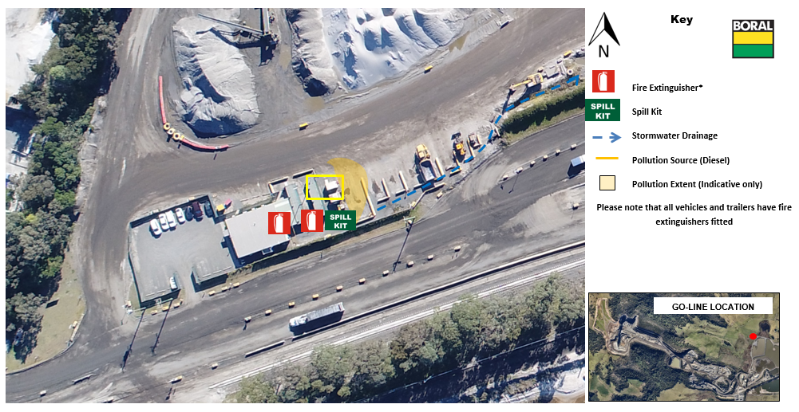
Figure 4: DSS Go-line Area Incident 1: Diesel/Hydrocarbon Spill
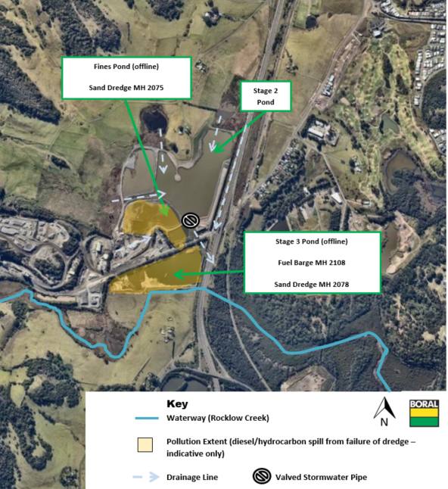
Figure 5: DSS Dredge Ponds Incident 1: Diesel/Hydrocarbon Spill
Please note spill kits and fire extinguishers are located on all barges and sand dredges. For more information relating to inventory of polluting substances and lists of hydrocarbon controls relating to Incident 1 please refer to Table 2 in Part A.
Table 10: Incident #2: Excessive Airborne Dust Response Actions
Incident #2 | Excessive airborne dust from stockpiled material, mobile plant or traffic areas causing material harm to the environment or significant impact to community. See Fig 6 & 7.  Actions Required:  - Employees, Contractor/Visitor to notify site representative of issue immediately.  - Dust suppression activity to commence immediately on stockpiles via water cart or other means. Any operations associated with disturbing the stockpiles, such as driving and dumping on, to be minimised or ceased.  - Daily monitoring to be undertaken to assess weather and site conditions  - Contact all relevant people/department (refer to Immediate Reporting Contact Sheet)
Alarm raising | Any personnel involved or witnessing incident to report to immediate supervisor and PIRMP actions to be implemented.
Emergency Controller | - Emergency Controller: Quarry Manager or delegate  - Call service provider: Quarry Manager or delegate  Periodic inspections and update reporting of site and stockpiles: Onsite supervisor or delegate
Scale of incident | Incident would be localised to the area surrounding stockpile area, with minimal external offsite impact.
Evacuate | Only if fire or explosion potential exists. Quarry Manager and any advice provided by Fire Department as part of attendance after immediate notification.
Communications | Internal:  - Quarry Manager or delegate to use contact sheet for all internal (Boral) contacts  External mandatory:  - Immediate Reporting Contact Sheet to be used  External non-mandatory:  - Contact neighbors affected (will be dependent on wind direction). The environmental representative is to be consulted as to which neighbours will be affected by a particular wind direction. See Table 5 Section 11 for the Neighbour Notification List.
Rescuer / respondent + safety checks | As per Site Emergency Plan or Fire Department as part of Immediate Reporting
Rescue + First Aid | As per Site Emergency Plan or Fire Department as part of Immediate Reporting
Clean up and  Waste disposal | All water carts to be placed on areas producing airborne dust. If necessary work must be ceased to control airborne dust. No disposal of waste required.
Reporting and re-preparedness | See HSEQ MS:  - Incident Reporting, Investigation and Action Management Standard (GRP-HSEQ 3-02)

For more information relating to inventory of polluting substances and lists of controls relating to Incident 2 please refer to Table 2 in Part A.

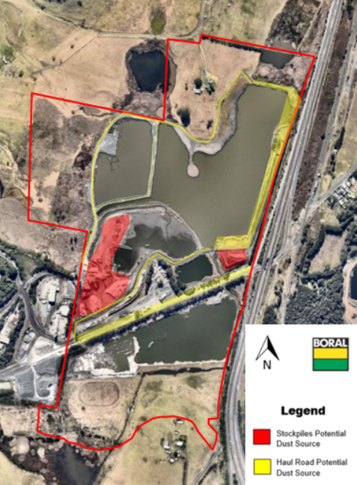
Figure 6: Incident 2: Sources of Dust Pollution at Dunmore Sand and Soil
Please note that pollution controls include operational response which is not included on these maps. See Table 1 in Section 7 for more detail on pollution controls for Incident #2.
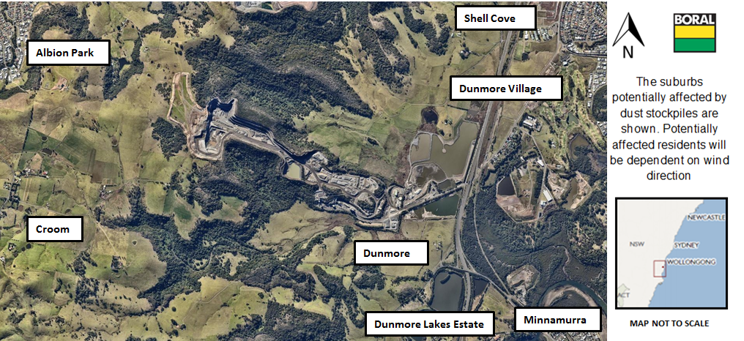
Figure 7: Incident 2: Potential Suburbs Affected by Dust Emissions under Adverse Conditions

Table 11: Incident #3: Uncontrolled Release of Stormwater Response Actions
Incident #3 | Uncontrolled release of sediment laden water from storage dams causing material harm to the environment. See Figure 8  Actions Required:  - Shutdown of processes and equipment associated with the release if safe to do so  - Activation of any associated storm water shut-off valves to isolate  - Contact all relevant people/department (refer to Immediate Reporting Contact Sheet)  - Ensure bund integrity is sound throughout the entire period of incident (i.e. periodic inspections)  - Contact local neighbours if going to be in inundated by rise of water  - Area to be restricted to Incident Response Personnel  - If any release from site onto unsealed soil/surface water - Environmental Consultants to be engaged to investigate and remediate contamination, if any  - Contact local contractor to rebuild dams immediately  - Contract local contractor to install ESC as required around the site.
Alarm raising | Any personnel involved or witnessing incident to report to immediate supervisor and PIRMP actions to be implemented.
Emergency Controller | - Emergency Controller: Quarry Manager or delegate  - Call service provider: Quarry Manager or delegate  - Spill Kit manager: Onsite supervisor or delegate  - Periodic inspections and update reporting of site and bund: Onsite supervisor or delegate
Scale of incident | Catastrophic failure of one or more sediment dams are likely to result in off-site impacts to water courses which would predominantly reduce water quality over a short period of time. As such, impact to the environment/human health is not considered to be significant.
Evacuate | Only if flood potential exists. Quarry Manager and any advice provided by Fire Department as part of attendance after immediate notification.
Communications | Internal:  - Quarry Manager or delegate to use contact sheet for all internal (Boral) contacts  External mandatory:  - Immediate Reporting Contact Sheet to be used  External non-mandatory:  - Contact Neighbours 5,6,7 and 8 in the case of a sediment dam failure affecting water quality downstream over an extended period of time. See Table 5 Section 11 for the Neighbor Notification List.
Rescuer / respondent + safety checks | As per Site Emergency Plan or Fire Department as part of Immediate Reporting
Rescue + First Aid | As per Site Emergency Plan or Fire Department as part of Immediate Reporting
Clean up and  Waste disposal | Depending on severity of incident, consultants to be contacted to advise on required clean-up.
Reporting and re-preparedness | See HSEQ MS:  - Incident Reporting, Investigation and Action Management Standard (GRP-HSEQ 3-02)

For more information relating to inventory of polluting substances and lists of controls relating to Incident 3 please refer to Table 2 in Part A.

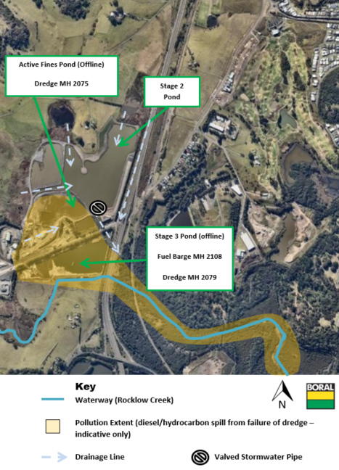

Figure 8: Incident 3: Overflow of Sediment Dams due to Flooding or Dam Failure
Please note that pollution controls include inspections and operational response which are not showed on these maps. See Table 2 in Section 7 for more details.

POLLUTION INCIDENT NOTIFICATION LOG
Person undertaking notification (Name/Function):
Date and time when first become aware of the incident:
Incident type:
Comments:

Initial immediate notification log
Appropriate Regulatory Authority | Time of call | Respondent’s name/function |  | Approximate call duration | Comments
EPA
Public Health Unit
Fire and Rescue NSW
Local Council
Safework NSW
Other: (including neighbours)
Other: (including neighbours)
Other: (including neighbours)
Other: (including neighbours)
Other:
Summary of initial communication:

Person undertaking notification (Name/Function):
Date and time when additional information become available:
Comments:

Immediate notification of further pertinent information (if applicable)
Appropriate Regulatory Authority | Time of call | Respondent’s name/function | Approximate call duration | Comments
EPA
Public Health Unit
Fire and Rescue NSW
Local Council
WorkCover
Other:
Other:
Summary of additional communication

IMMEDIATE NOTIFICATION SHEET SUMMARY
Table 10: Internal Reporting List
Name | Function | Phone Number | Mobile Number
 | Dunmore Sand & Soil Quarry Manager
 | Dunmore Sand & Soil Quarry Supervisor
 | Environmental Business Partner
 | Environment Manager – NSW/ACT
Whilst personal contact details for the following are available in the PIRMP Controlled Version they do not appear in this public document

Table 11: External Reporting List
Government Authority – compulsory notifications | Emergency notification phone number
EPA – Environment Line | 131 555
Fire and Rescue NSW (FRNSW) | 1300 729 579
Shellharbour City Council | 02 4221 6111
Public Health Unit (South East Sydney / Illawarra AHS) – Wollongong SESI PHU | HealthLink (24 hr) - 0 - 1800 063 635  Head Office – Wollongong - 0- 4221 6700
Safework NSW | 131050 Company ABN asked: 51 000 756 507
Government Authority – contact if relevant | Emergency notification phone number
Roads and Maritime Services (road spills) | 132 701
Police and Ambulance | 000
Natural Access Resources Regulator | 1800 633 362
Bushfire Control Officer | 1800 049 933
Poisons Information Centre | 131 126
Endeavour Energy (power line emergencies) | 131 003

Table 12: Neighbour Notification List
Neighbour Notification List (contact if relevant)
Reference | Contact Name | Address | Contact Details
1
2
3
4
5
6
Whilst personal contact details for the following are available in the PIRMP Controlled Version they do not appear in this public document

